# WORKING OF TASK MANAGER APPLICATION

## Adding/Editing/Deleting/ Viewing Tasks:

* In the home page after launching the URL, click on **ADD TASK**.

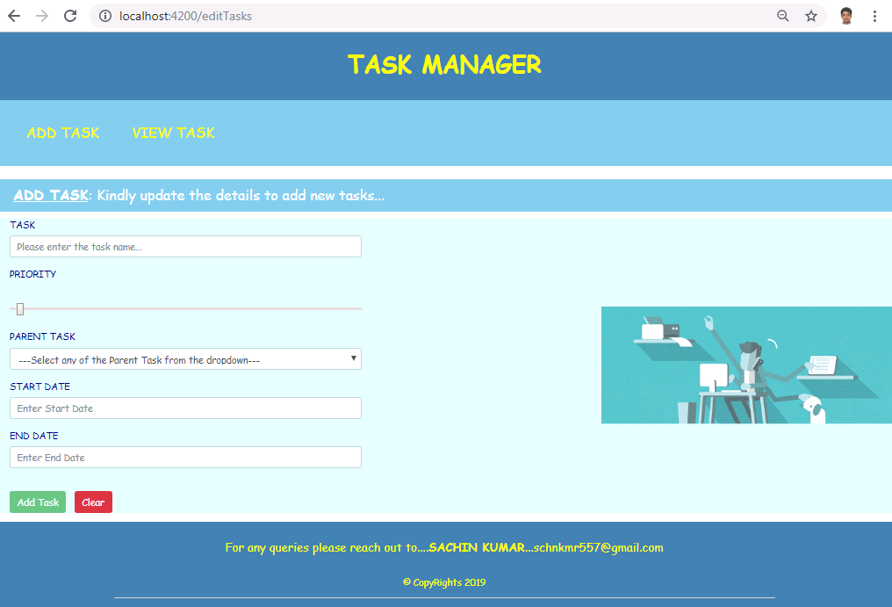

* Enter Task Details with valid data and Click **Add Task** to create new task.

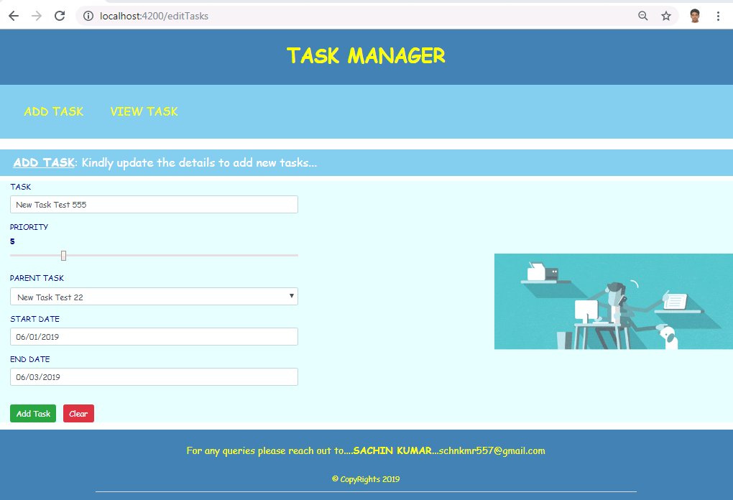

* If the data entry is successful we get a validation message as follows. Else an appropriate message is displayed.

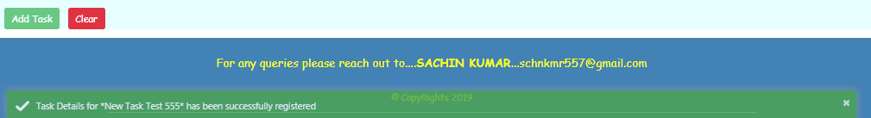

* An entry added will be displayed in **VIEW TASK** section.

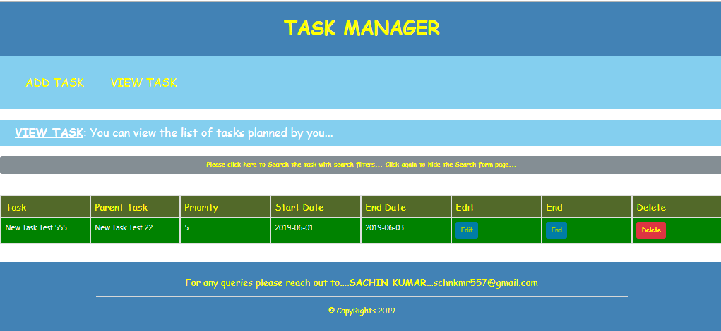

* All the tasks added will be visible in View Task bar.

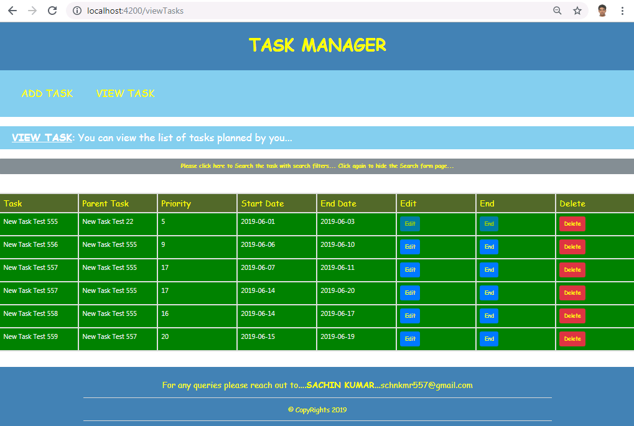

* On clicking on **Edit**, the Task record can be Edited if required in the following page.

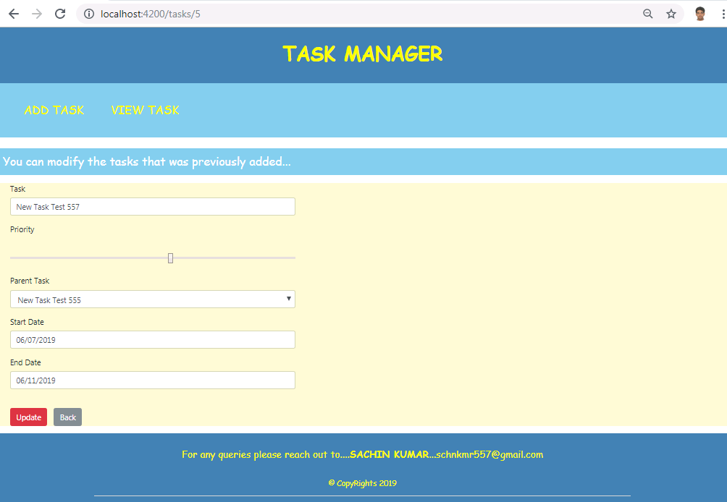

* User can update the task and click on update. If all validations pass Update will be successful. Click on back to View Updated Task records.

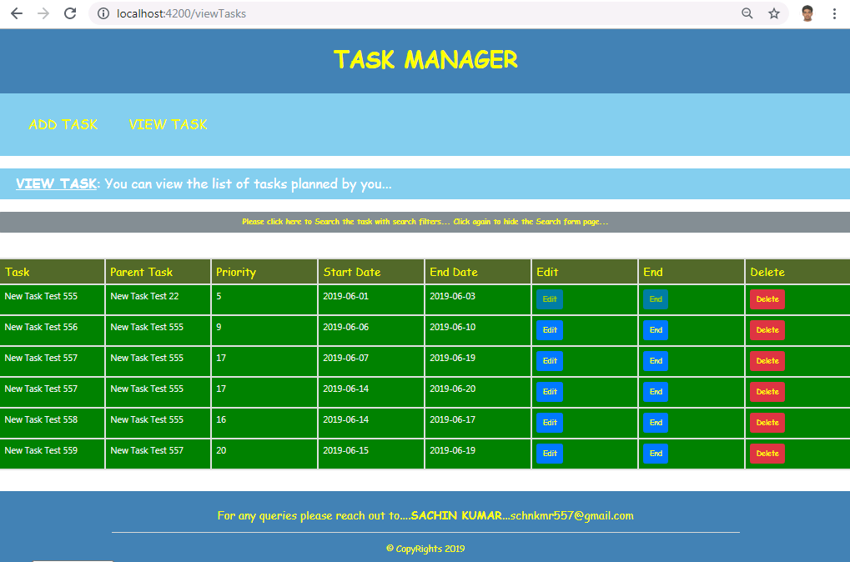

* In the above illustration End date for a record is updated.
* User also has an option to End or Delete a Task.
* If delete is successful, the following message is seen.

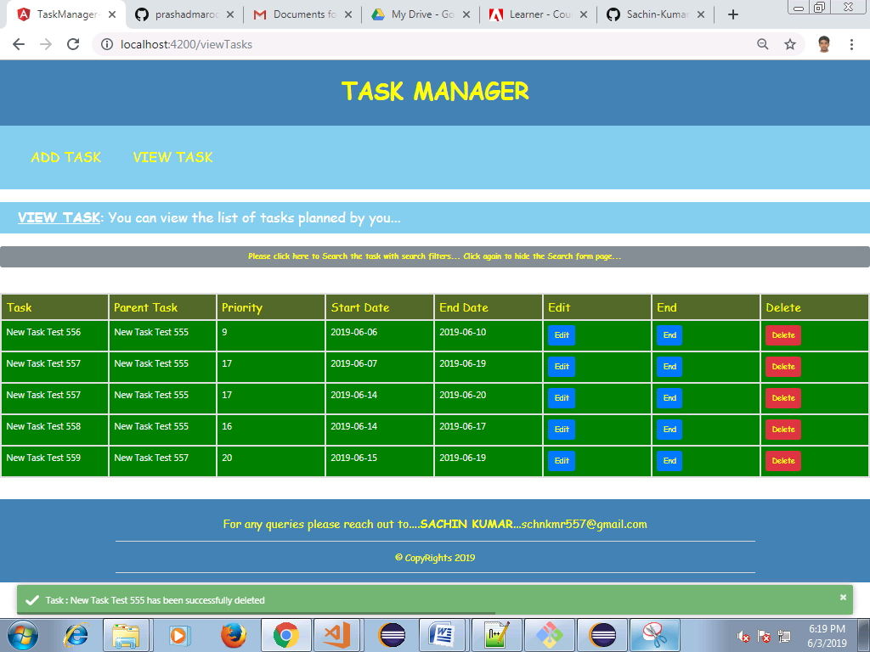

* If the End Date is less than the current date, the task can't be terminated (Button will be disabled) . Only Delete is permitted. The following validation message pops up if the End Date is a future date.

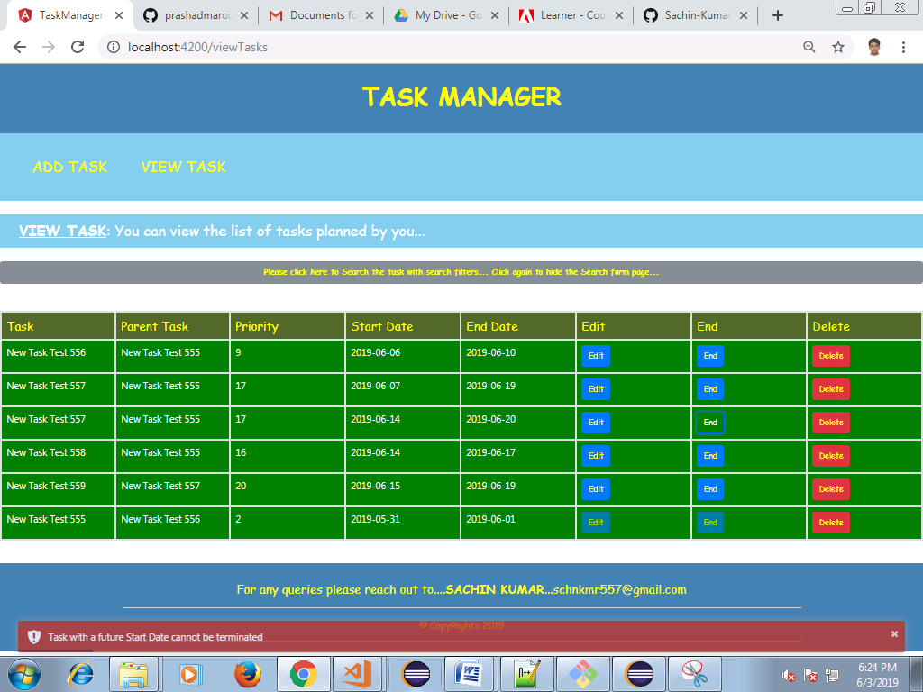

* The user can Search the tasks entered by clicking **"Please click here to Search the task with search filters... Click again to hide the Search form page..."**

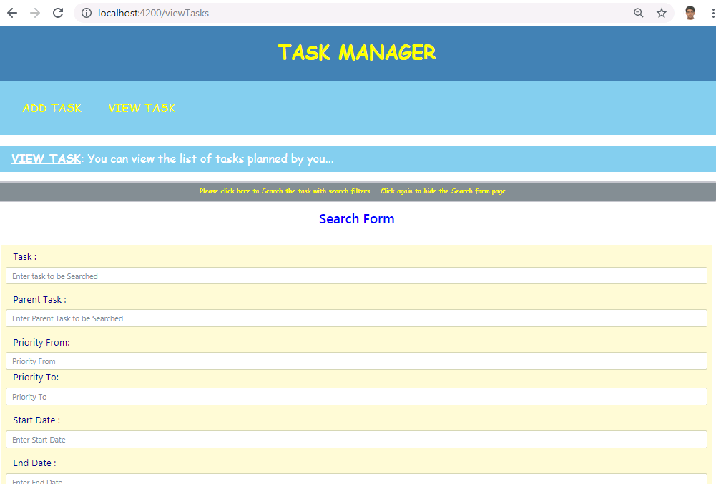

* The Search form is very particular in displaying the Task records. Based on the Search form field filters only the records for the fields entered in the filter will be displayed.

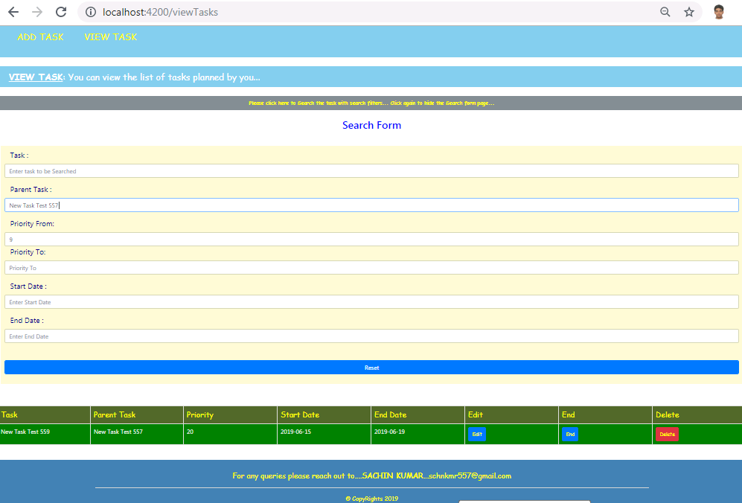

* User can click back on "**Please click here to Search the task with search filters... Click again to hide the Search form page..."** to hide the Search page.
* The filter applied to search will be applicable even after you hide the search page and hence only the filtered Task records will be visible. If at all the user intends to view remaining tasks, the filter has to be reset.